Vrixzandro C. Eliponga System Administration and Maintenance

BT1203 05 Laboratory Exercise 1

* Result of **ps** command

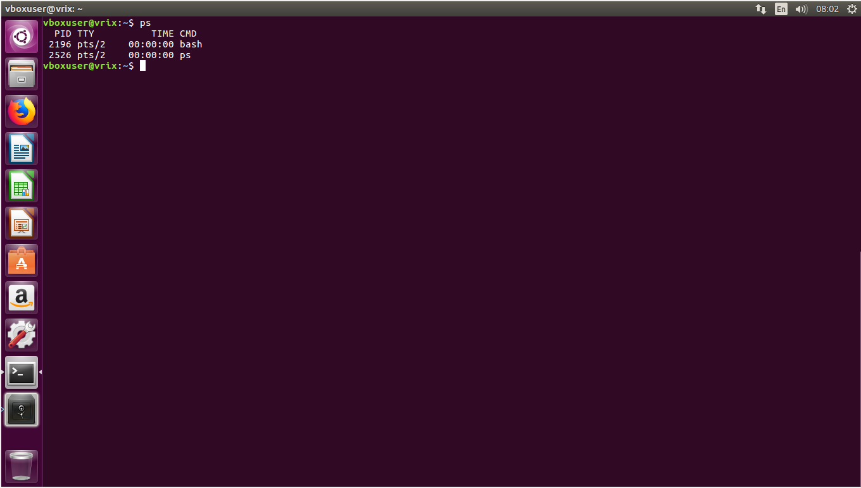

* 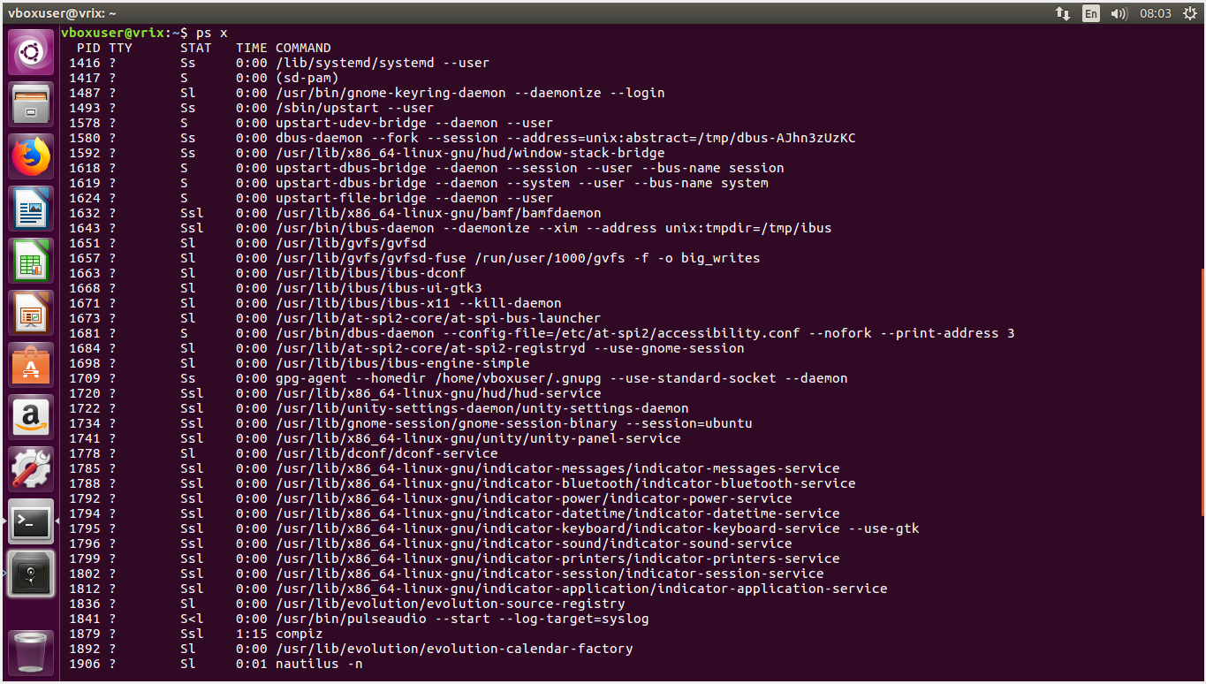Result of **ps x** command
* Result of **ps aux** command

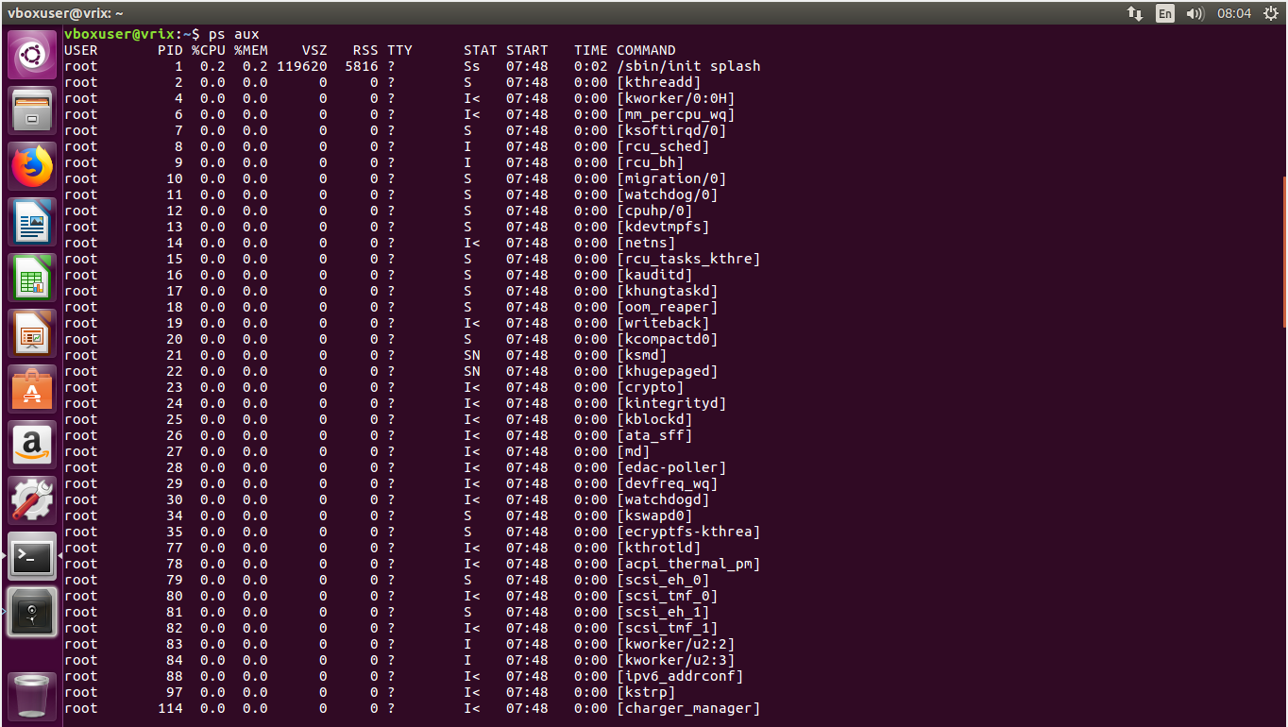

* Output of the **top** program

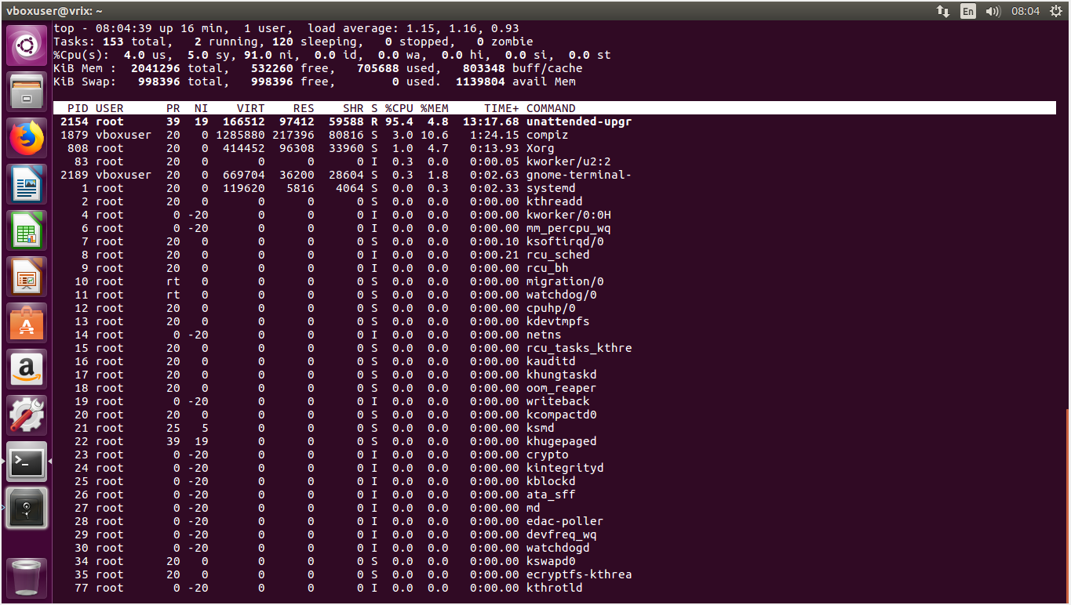

* Result of the **ps** command upon placing **top** in the background

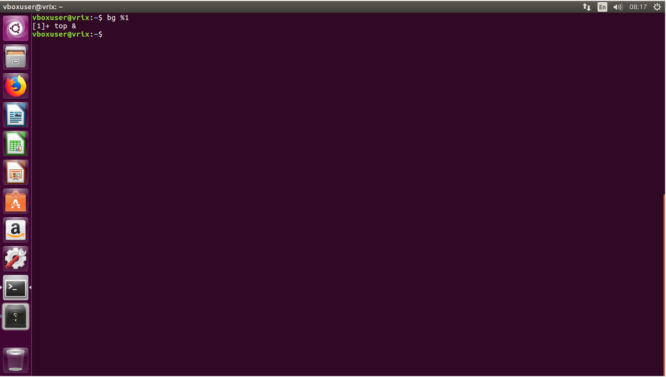

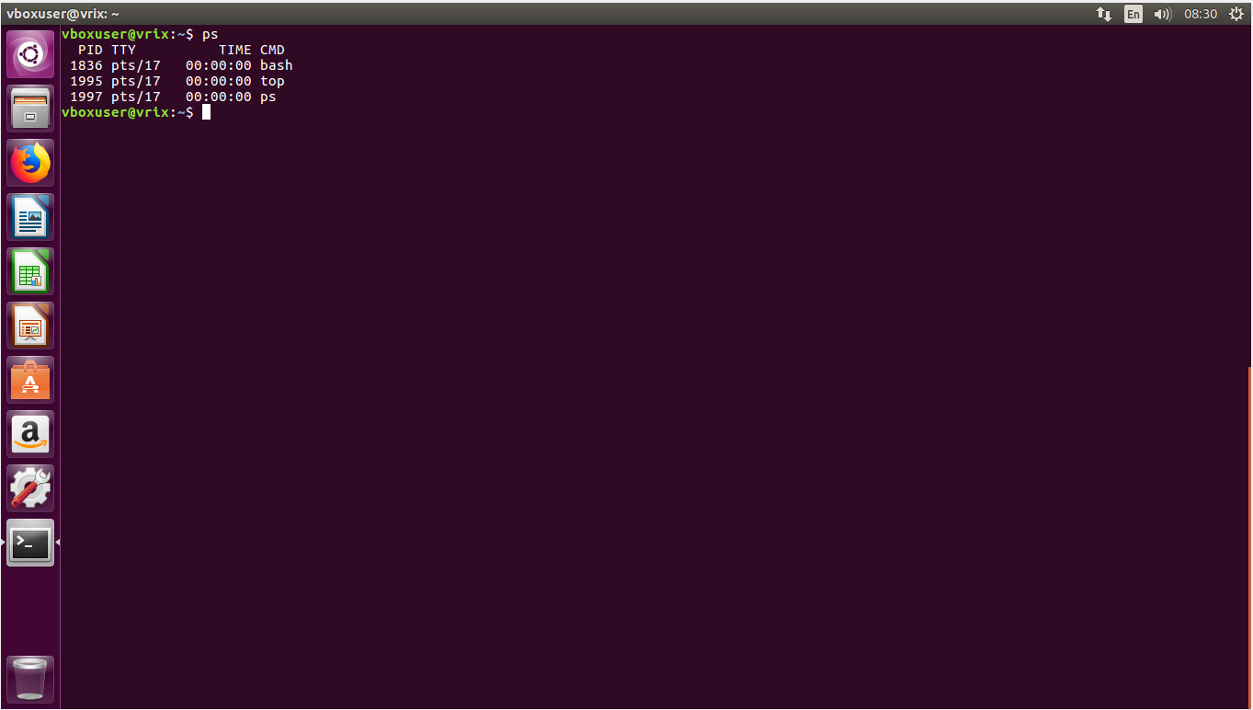

* Result of the **jobs** program

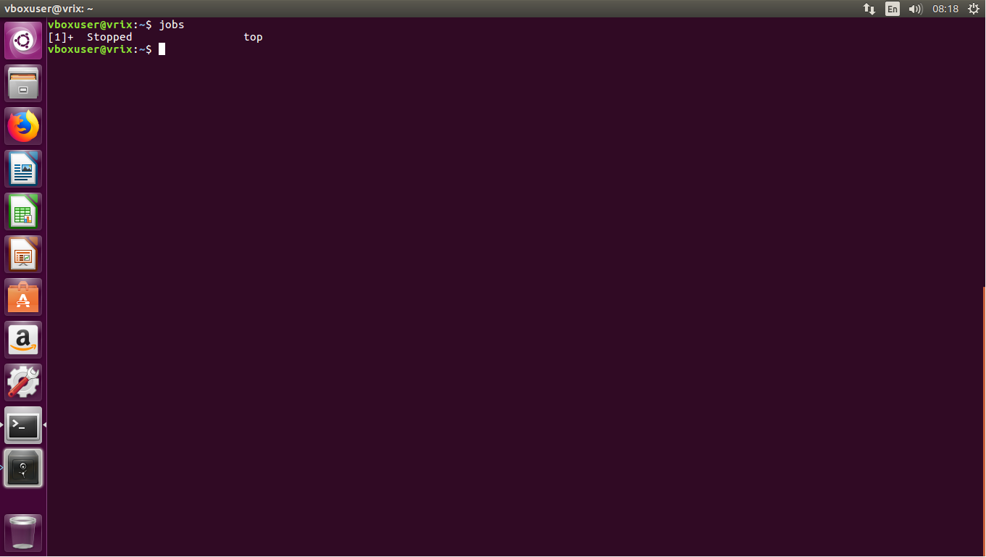

* Result of the **ps** command upon returning **top** to the foreground

